Introduction to Statistics

Chapter 1: Stats Starts Here
Date: ________________________________

Objectives:

Students will be able to understand that data are information in a context.

Students will be able to treat variables as either categorical or quantitative.
Main Idea | Notes
What Is (Are?) Statistics? | Statistics (the discipline) is a way of ________________________________, along with  collection of _________________________________ and ______________________________, designed to  help us understand the world.  Statistics (plural) are ________________________________________________________________________.  Data are values with a _______________________________________.
Example 1:  Think-Pair-Share | What are some examples of how data is used in the world? Write as many ways you can think of.
Example 2: Defining Statistics in One Word | Just for fun: Summarize each discipline in a few words.  - Economics:  - Biology:  - Psychology:  - Anthropology:  - Engineering:  - Statistics:
What is Statistics Really About? | Statistics is about _______________________________________________.  Statistics helps us make sense of the world by seeing past the ____________________________  to find ________________________________________ and ________________________________________.  All measurements are ______________________________________________, since there is variation that we cannot see.  Statistics helps us to understand the real, __________________________________________________ in which we live.
In Summary | Statistics can be (and is) fun!  Statistics gives us a way to work with the _____________________________________________ in the world around us.  We are embarking on an exciting journey of learning Statistics…
Classwork: Writing Assignment | Read Time magazine “America: By the Numbers.”  Write a 1-page reflection answering the following questions. Use textual evidence to support your claim.  - Why is finding the “Average American” such a challenge?  - Why can using averages to define Americans be so problematic?  - How do you compare to the examples of the “Average American” that are given in this article?  - Statistics is all about variation. How does this article show that?  - Do you want to be the “Average American”? Explain why or why not.
Video: Shift Happens | https://www.youtube.com/watch?v=uqZiIO0YI7Y&t=44s  Discussion topic: What are your thoughts on this video? What did you find interesting or surprising?
Classwork: | M&M’s Activity
What are Data? | Data are a collection of ___________________________________, ___________________________________,  ________________________________, or _______________________________________________ that provide information.  Not all data represented by numbers are ___________________________________________ data  What is an example?  Data are useless without their _______________________________________.
The 5 W’s and H | To provide context we need the 5 W’s and H:  _______________________  _______________________ (and in what units)  ________________________  _______________________  _______________________ (if possible),  ________________________
The Who | The Who of the data tells us the __________________________________________________________ for  which (or whom) we have collected data.  Individuals who answer a survey are called _______________________________________________.  People on whom we experiment are called ____________________________________ or  ___________________________________________________.  Animals, plants, and inanimate subjects are called ________________________________________.
The What and Why | _______________________________________ are characteristics recorded about each individual.  The variables should have a name that identify _____________________has been measured.  Some variables have ____________________________ that tell how each value has been measured and tell the scale of the measurement.  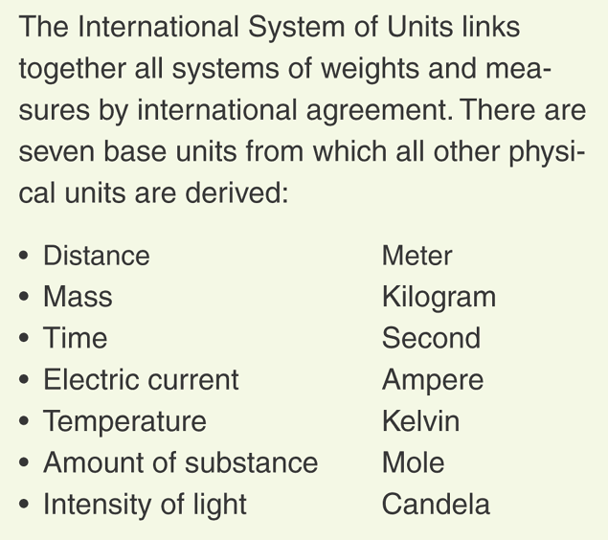  A categorical (or qualitative) variable names ________________________________________ and answers questions about how cases fall into those categories.  What are some examples of categorical variables?  A quantitative variable is a __________________________________________________ variable  (with units) that answers questions about the quantity of what is being measured.  What are some examples of quantitative variables?
The What and Why (Cont.) | Identifier variables are categorical variables with _______________________________________ individual in each category.  What are some examples of identifier variables?  Don’t be tempted to analyze identifier variables!
The Where, When, and How | _____________________________ and ______________________________ give us some nice information about the context.  Example: Values recorded at a ______________________________________________________________  may mean something different than similar values recorded at a  _____________________________________________________________________.  ____________________ the data are collected can make the difference between insight and nonsense.  What are some types of surveys that are usually useless?
Three Steps to Doing Stats Right | There are three simple steps to doing Statistics right:  - _______________________________ first. Know where you’re headed and why.  - _______________________________ is about the mechanics of calculating statistics and making graphical displays.  - ________________________________ what you’ve learned. You must explain your results so that someone else can understand your conclusions.
Practice Problem: | Suppose a Consumer Reports article (published in June 2005) on energy bars in California gave the brand name, flavor, price, number of calories, grams of protein, and grams of fat. They obtained this information by testing the energy bars in a laboratory. Identify the following:  Who:  What (Variables):  Where:  When:  Why:  How:  Categorical Variables:  Quantitative Variables (with units):
Homework: | Chapter 1 Homework: Stats Starts Here

