Name ___________________________________________ Date ______________
INTRO TO STATISTICS – MS. KLIMCZUK

Chapter 2 Example Problems

Example 1: Sneakers
Sneaks/Gender | Girls | Boys | Totals
Wearing | 14 | 21 | 35
Not Wearing | 20 | 3 | 23
Totals | 34 | 24 | 58
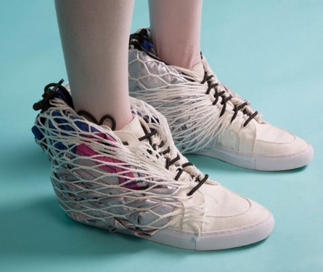

- What is the marginal frequency distribution of wearing sneakers?

- What is the marginal frequency distribution of girls?

- What percent of sneaker-wearers are girls?

- What percent of the girls are sneaker-wearers?

- What percent of the class are girls who are wearing sneaks?

- Sketch a SEGMENTED BAR GRAPH.

- Are the variables gender and wearing sneaks associated or independent? How do we decide?

Example 2: Politics

Politics/Gender | Girls | Boys | Totals
Liberal | 2 | 1 | 3
Moderate | 29 | 13 | 42
Conservative | 2 | 8 | 10
Totals | 33 | 22 | 55

- What is the marginal frequency distribution of moderate?

- What percent of liberals are girls?

- What percent of the girls are liberals?

- What percent of the class are girls with moderate political views?

- Sketch a SEGMENTED BAR GRAPH.

- Are the variables gender and political view associated or independent? How do we decide?

