Introduction to Statistics

Chapter 2: Displaying and Describing Categorical Data
Date: ________________________________

Objectives:

Students will be able to analyze categorical variables.

Students will be able to see how two categorical variables are related by putting counts and percentages into a contingency table.
Main Idea | Notes
Three Rules to Data Analysis: | There are three rules to data analysis:  - ___________________________________________________________________________ - things may be revealed that are not obvious in the raw data - things to think about.  - ___________________________________________________________________________ - important features and patterns in the data will show up. You may also see things that you did not expect.  - ___________________________________________________________________________- the best way to tell others about your data is with a well-chosen picture.
Frequency Tables:  Example: Drawing a Relative Frequency Table | For categorical variables, we often compile data by ______________________________________  the number of values in each ______________________________________________ and display  these counts in a _________________________________________________________________.  Example:  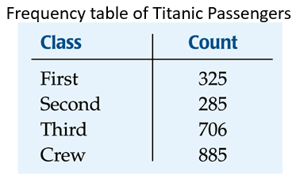  A relative frequency table is similar, but shows __________________________________________  instead of _________________________________________.  Now make a relative frequency table of the Titanic passengers below:
The Area Principle | You might think that a good way to show the Titanic data is with this display:  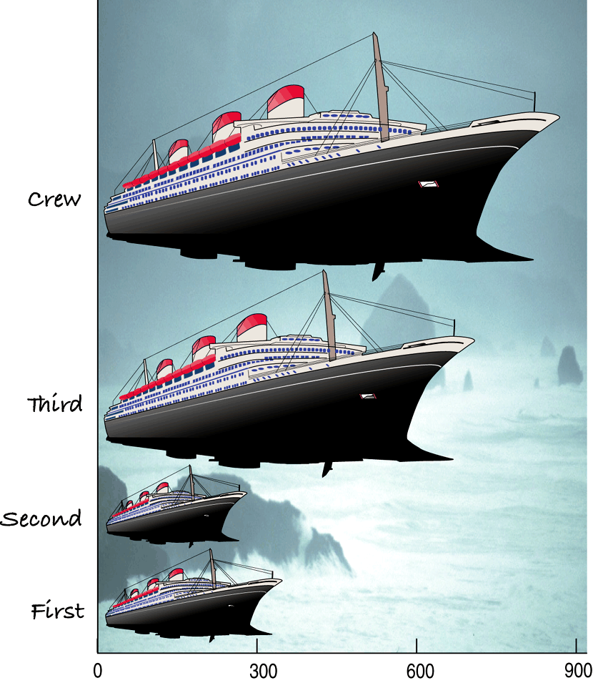  Write what you think is wrong with this display:  This shape display violates the _______________________________________________.
The Area Principle (Cont.) | The ship display makes it look like most of the people on the Titanic were  ___________________________________________________, with a few passengers along for the ride.  When we look at each ship, we see the ____________________________________ taken up by  the ship, instead of the ______________________________________ of the ship.  Question: How do you think we can fix this graph?
Bar Charts | __________________________________ display the distribution of a _______________________________ variable, showing the counts side-by-side.  Draw a bar chart of the Titanic data below:  ________________________________________________________________________________________ display  the ___________________________________________________ of counts.  Draw a relative frequency bar chart of the Titanic Data below:
Pie Charts | When you want to display parts of a whole, you can use a __________________________________.  Pie charts display the _______________________________ or ________________________________________.  Draw a pie chart of the Titanic data below:
Classwork: Violation of the Area Principle | - Find a graph on the internet that is an example of a violation of the area principle.  - Explain how the graph is misleading and what should be changed to improve it.  - Create a new graphical display of the data that does not violate the area principle. For example, you can create a well-drawn bar graph or pie chart.  - We will share these with the class.
Contingency Tables  Contingency Tables (Cont.) | Contingency tables allow us to look at ___________________________ categorical variables at the same time.  They show how individuals are distributed across each ____________________________________,  contingent on the second _____________________________________.  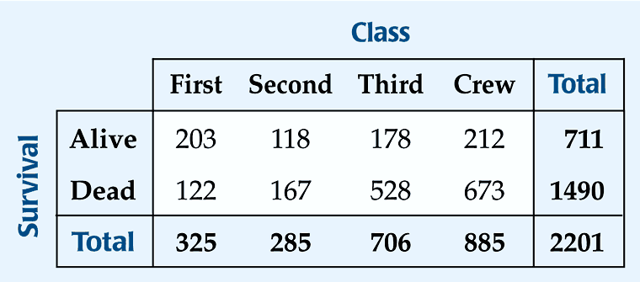  What two variables are we looking at here??  The ____________________________ (right and bottom) of a contingency table should have row and column totals (ADD THEM).  We use these totals to calculate ________________________________________________.  What is the marginal distribution of alive?  What is the marginal distribution of second class?  What is the marginal distribution of dead?  What is the marginal distribution of third class?  What is the marginal distribution of crew?  Each cell of the table gives a _______________________for a combination of variables.  What does the second cell in the crew column tells us?  What does the first cell in the second-class column tells us?  What does the second cell in the third-class column tells us?
Conditional Distribution | A ____________________________________________________________________________ shows the distribution of one variable for just the individuals who satisfy some condition on another variable.  The following is the conditional distribution of ticket Class, conditional on being Alive:  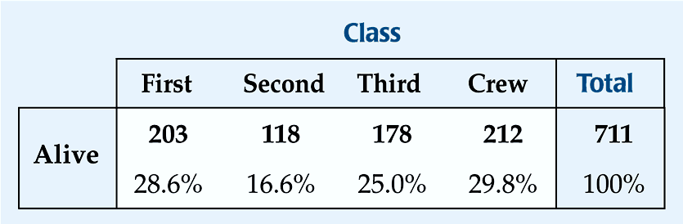  Now, create the conditional distribution of ticket Class, conditional on being Dead:
Conditional Distribution (Cont.) | Is there a difference in class for those who survived and those who perished?  Now you can make two pie charts for the two distributions.  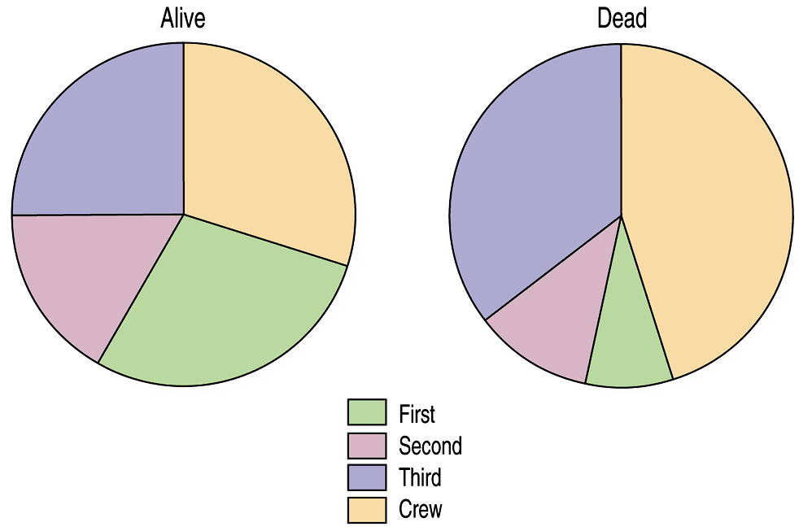  Is the distribution of Class for the survivors different from that of the non-survivors? Explain.  Do you think that Class and Survival are associated? Explain.  So, is Class and Survival independent of each other? Why or why not?  Independence: The variables are considered independent when the distribution of one variable is the same for all categories of the other variable.
Segmented Bar Charts | A _____________________________________________________________________________ displays the same  information as a __________________________________, but in the form of bars instead of circles.  Each bar is treated as the _____________________________________ and is divided into segments  corresponding to the ____________________________________________ in each group.  Draw the segmented bar chart for ticket Class by Survival status:  Is Class and Survival independent of each other? Why or why not? Use the segmented bar graph to explain your answer.
Classwork/  Homework: | Chapter 2 Example Problems  Chapter 2 Review for Test

