Name _____________________________________________ Date ____________
INTRO TO STATISTICS – MS. KLIMCZUK
Chapter 3 Classwork: Thinking about Shape (In Pairs)
- Would you expect distributions of these variables to be uniform, unimodal, or bimodal? Symmetric or skewed? Explain why.

a) The number of speeding tickets each student in the senior class of a college has ever had.

b) Players’ scores (number of strokes) at the U.S. Open golf tournament in a given year.

c) Weights of female babies born in a particular hospital over the course of a year.

d) The length of the average hair on the heads of students in a large class.

e) Ages of people at a Little League game.

f) Number of siblings of people in your class.

g) Pulse rates of college-age males.

h) Number of times each face of a die shows in 100 tosses.

- The histogram displays the sugar content (as a percent of weight) of 49 brands of breakfast cereals.

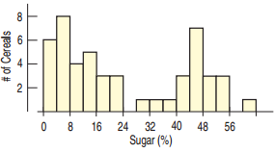

a) Describe the shape of this distribution.

b) What do you think might account for this shape?

- The display shows the heights of some of the singers in a chorus, collected so that the singers could be positioned on stage with shorter ones in front and taller ones in back.
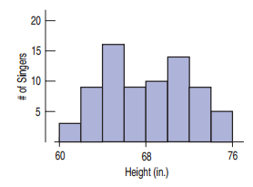
a) Describe the shape of this distribution.

b) What do you think might account for this shape?
4. The histogram shows the sizes (in acres) of 36 vineyards in the Finger Lakes region of New York.
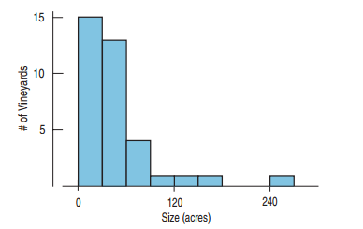
a) Approximately what percentage of these vineyards are under 60 acres?

b) Write a description of the shape of this distribution.

- One of the authors collected the times (in minutes) it took him to run 4 miles on various courses during a 10-year period. Here is a histogram of the times.
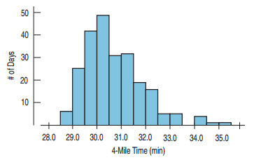
- Describe the shape of the distribution and summarize the important features.

- What is it about running that might account for the shape you see?

