Introduction to Statistics

Chapter 3: Displaying and Summarizing Quantitative Data
Date: ________________________________

Objectives:

Students will be able to THINK about summarizing quantitative variables.

Students will be able to make pictures of quantitative data to help us see the story data have to TELL.

Students will be able to TELL what they see about the distribution by talking about shape, center, spread, and any unusual features.
Main Idea | Notes
Dealing with a lot of Numbers | When we look at large sets of quantitative data and summarize it, what do you think is the best thing to do?  We can’t use bar charts or pie charts for quantitative data. Those displays are for what kind of variables?
Histograms  Histograms (Cont.) | Making a Histogram:  Divide the range of x-values into __________________________________________________called bins.  The _____________________________________ in each bin display the distribution of the variable.  This histogram shows the distribution of the magnitudes of earthquakes:  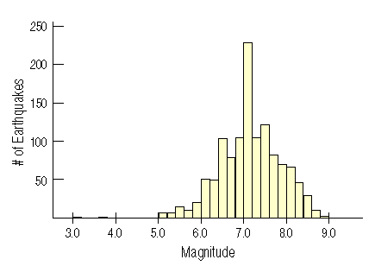  How does this display differ from a bar chart?  A histogram plots the ____________________________________________ within each bin as the heights of the bars (like a bar chart).  It displays the _________________________________________________ at a glance.  This is what our variable (‘magnitude’) “looks like”:  A relative frequency histogram displays the _________________________________________of cases  in each bin instead of the ____________________________________.  Here is a relative frequency histogram of earthquake magnitudes:  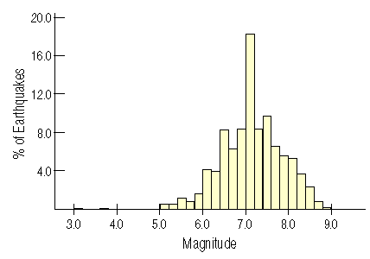
Stem-and-Leaf Display  Constructing a Stem-and-Leaf Display | This is an example of a stem-and-leaf display with split stems:  Key: 8/8 = 88 beats per minute  Compare the histogram and stem-and-leaf display for the pulse rates of 24 women at a health clinic.  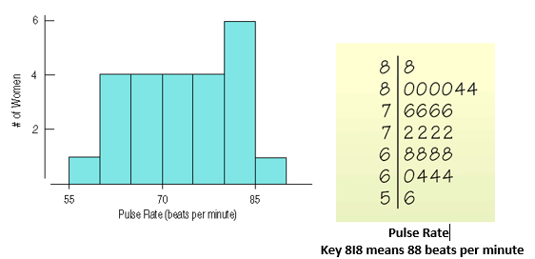  - Which graphical display do you prefer? Why?  - Which would be easier to make by hand? Why?  - How are the two graphs similar?  - How are the two graphs different?  This is how you make a Stem-and Leaf display:  First, cut each data value into _______________________________________________________ (“stems”)  and ________________________________________________(“leaves”).  Use the _________________________________ to label the bins.  Use only _______________________________ for each leaf - round the data values after the stem.
Dotplots: | A dotplot is a very simple display. Just place a ____________________ along the axis for each data point.  This dotplot shows Kentucky Derby winning times, plotting each race as its own dot:  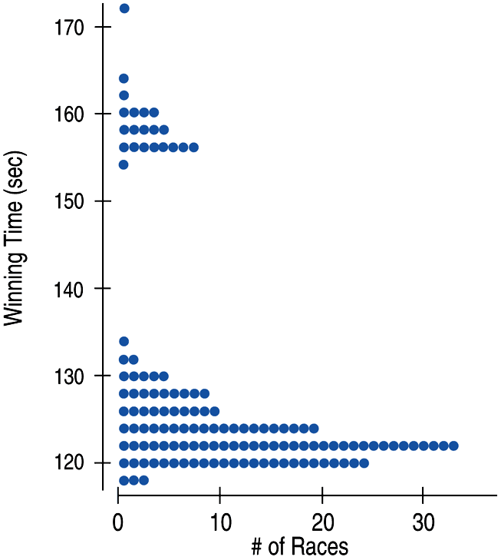  Dotplots can be displayed __________________________________________________or  _________________________________________.
Always THINK Before you Draw | Remember the “Make a picture” rule?  Think carefully about ______________________________________________ of display to make.  Before making a stem-and-leaf display, a histogram, or a dotplot, check the  ________________________________________________________________________________: The data are values of a quantitative variable whose units are known.
Classwork: | Creating different types of displays from “Siblings Data”
Describing Distributions | When asked to describe the distribution of a quantitative variable, you must discuss four things:  - ______________________________________________________  - ______________________________________________________  - ______________________________________________________  - ______________________________________________________  “CUSS”
What is the Shape of the Distribution?  What is the Shape of the Distribution?  (Cont.)  What is the Shape of the Distribution?  (Cont.) | When thinking about shape, ask yourself the following:  - ____________________________________________________________________________________________  - ____________________________________________________________________________________________  - ____________________________________________________________________________________________  HUMPS:  Humps in a histogram are called _______________________________________.  Histograms with one main peak are ______________________________________________.  Histograms with two peaks are ________________________________________________.  Histograms with three or more peaks are called _____________________________________.  Histograms where the bars are around the same height is called __________________________.  What is the shape of this distribution below? ________________________________  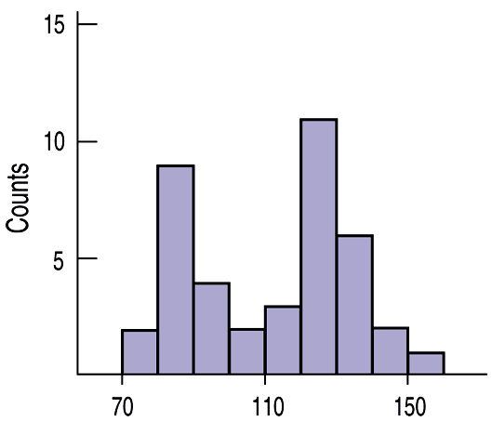  What is the shape of this distribution below? ________________________________  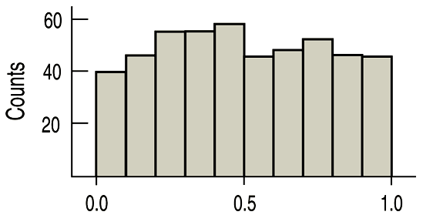  SYMMETRY:  If you can fold the histogram down the middle and have the edges match pretty closely,  the histogram is _________________________________________________.  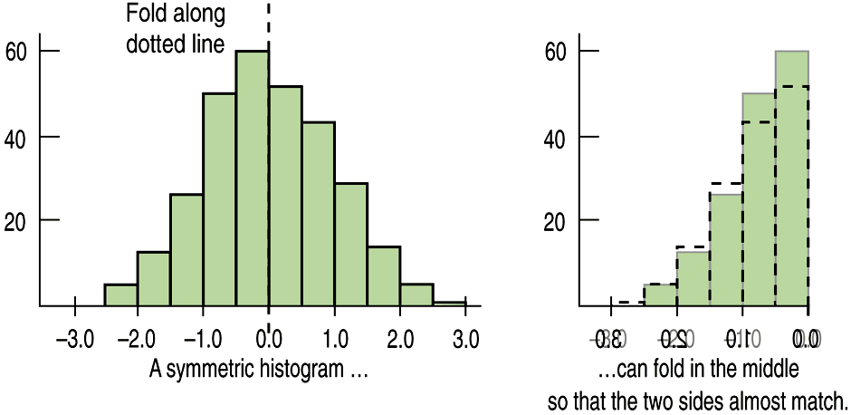  The thinner ends of a distribution are called the _________________________________.  When a distribution is not symmetric, the distribution is skewed _________________________  ____________________________________________________________________________________________________.  What direction is the skew for each of the graphs below?  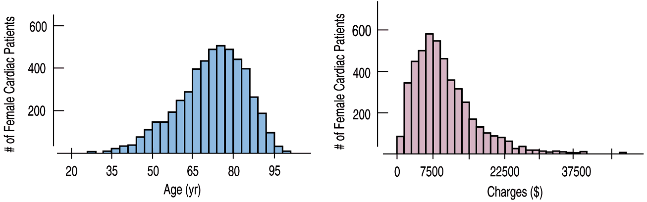  ANYTHING UNUSUAL:  Sometimes it’s the __________________________________________________________________ that tell us something interesting about the data.  You should always mention any ________________________________________________ that stand away from the body of the distribution.  Are there any gaps in the distribution? If so, we might have data from ____________________  ___________________________________________________________________________________________________.  Examples: What is unusual about each of the histograms?  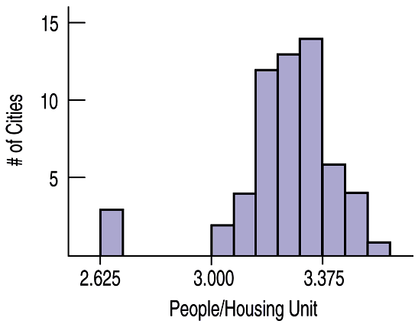  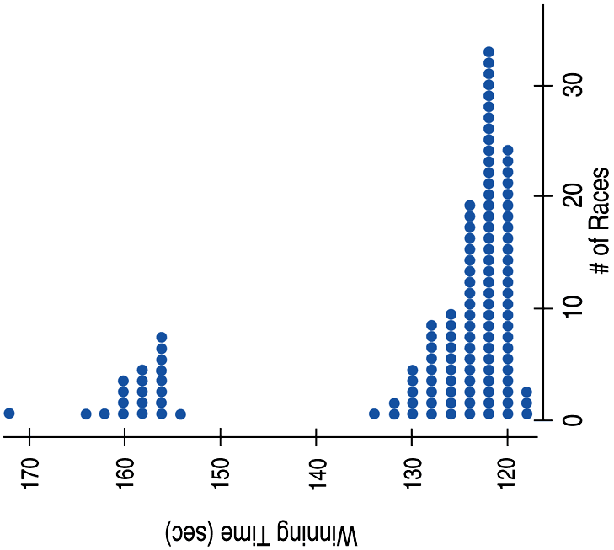
Classwork: | Chapter 3 Classwork: Thinking about Shape
Where is the Center?  Example: Finding the Median | It’s easy to find the center when a distribution is uni-modal and symmetric - it’s right in  the _______________________________________________.  It’s not so easy to find the center of a __________________________________________________ or a  _________________________________________________________ distribution.  The first type of center is the MEDIAN.  The median is the value with exactly ______________________________ the data values below it and half above it.  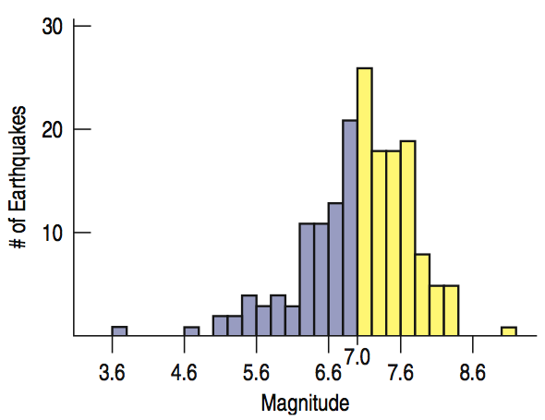  Note: We will talk about the mean (the other measure of center) in a bit!  What is the median of each set of data?  - {3, 6, 2, 8, 9, 7}  - {5, 8, 5, 2, 3, 4, 5}  - {10, 2, 3, 5, 9, 11, 16}
What is the Spread?  What are Quartiles? | Statistics is about _______________________________________________________. Are the values of the distribution tightly clustered around the center or spread out?  Always report a measure of ____________________ along with a measure of ____________________ when describing a distribution.  The _________________________ is the difference between the maximum and minimum values:  Range = max – min  What is a disadvantage of using the range?  The _______________________________________________________________________________________ (IQR) lets us ignore extreme data values and concentrate on the middle of the data.  The difference between the ___________________________________________________ is called the inter-quartile range (IQR).  IQR = upper quartile – lower quartile  Quartiles divide the data into ______________________________ equal sections.  One quarter of the data lies ____________________________the lower quartile, Q1.  One quarter of the data lies _______________________________ the upper quartile, Q3.  The quartiles border the ________________________________ half of the data.
Examples: Finding the Range, Median Quartiles, and Interquartile Range  Spread | Find the range, median, quartiles, and IQR for each data set.  - {3, 6, 9, 10, 14, 17}  Range = ______________  Median = ________________  Q1 = ____________________  Q3 = ____________________  IQR = __________________  - {2, 8, 11, 16, 25, 54, 76}  Range = ______________  Median = ________________  Q1 = ____________________  Q3 = ____________________  IQR = __________________  - {9, 2, 16, 54, 33, 22, 7}  Range = ______________  Median = ________________  Q1 = ____________________  Q3 = ____________________  IQR = __________________  The lower and upper quartiles are the _____________ and _____________percentiles of the data, so…  The IQR contains the middle ___________________ of the values of the distribution, as shown:  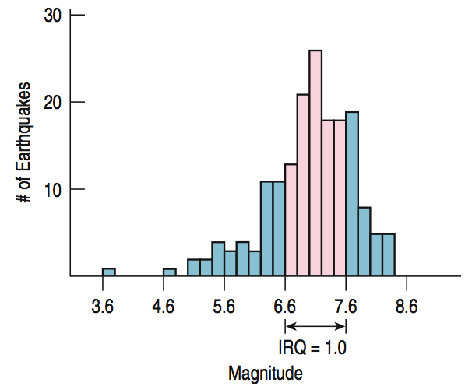
5-Number Summary | A distribution’s 5-number summary reports its ___________________________________,  ____________________________, and __________________________________________________________.  The 5-number summary for tsunami earthquake Magnitudes looks like this:  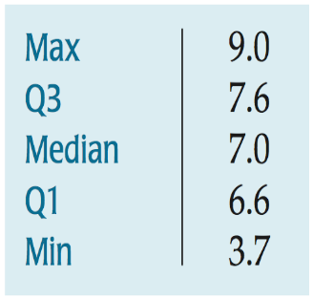
Example: 5-Number Summary | Report the 5-Number Summary for the following data set:  {6, 9, 24, 35, 46, 57, 68}
What about the Mean? | The mean is the other measure of center. It is also known as the ___________________________.  Here is the formula for finding the mean:  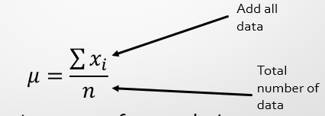  New symbol μ (mu) = mean of a population  What is the mean of this data set? {2, 3, 4, 5, 6}  μ = __________________.  The mean “feels” like the ________________________________________ because it’s the point where a histogram balances!  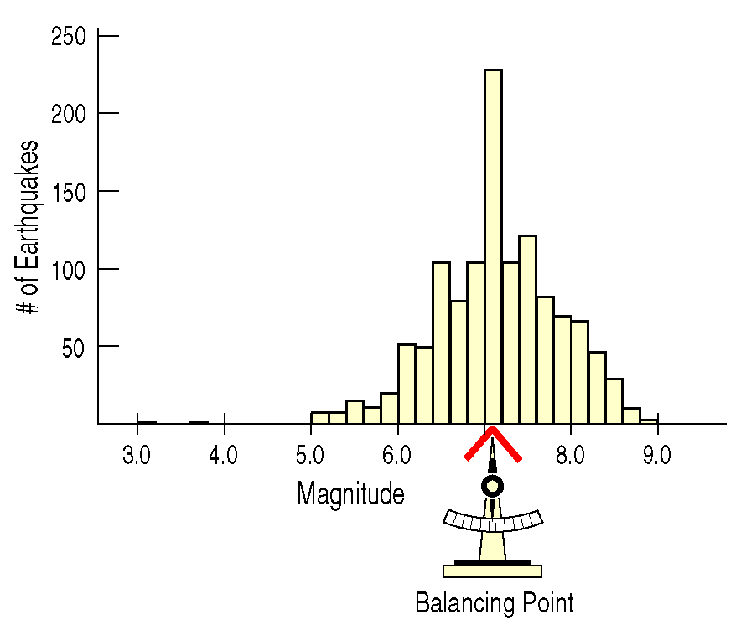
Examples: Finding the Mean | Find the mean of each of the following:  - {1, 2, 5, 7, 9, 10, 11, 12}  - {34, 56, 76, 45, 24, 32, 12}
Mean or Median? | If the data is skewed, would you use the mean or median as a measure for the center?  Why?  To choose between the mean and median, start by looking at the data.  If the histogram is symmetric and there are no outliers, use the ____________________________.  If the histogram is skewed or with outliers, use the __________________________________________.
Handout: | How Shape Changes Measures of Center
Classwork: | Measuring Shape and Center Worksheet
Classwork: | Creating Boxplots Worksheet
Fish Tank Method | Matching Histograms to Boxplots  (Take notes on the “Fish Tank Method” below)
Fish Tank Method (Cont.)

Classwork: | Matching Boxplots to Histograms Activity:  Cut out each of the graphs. On a separate piece of paper, glue all the matches together and write a brief explanation as to why you matched up those graphs. You can draw fish tanks if it helps you.
Standard Deviation | A more powerful measure of spread than the IQR is _________________________________________, which takes into account how far each data point is from the mean.  “Standard Deviation is the average  distance to the mean.”  Like mean, standard deviation gets pulled by _________________________________________ and  ________________________________________________________________.  When describing a unimodal/symmetric distribution, use ______________________________for  center and __________________________________________________________ for spread, otherwise use  the __________________________________ for center and ___________________________ for spread.
How do we find Standard Deviation?  How do we find Standard Deviation? (Cont.)  How do we find Standard Deviation? (Cont.) | Now we will figure out how to find the standard deviation…  - First, look at the data set {2, 3, 4, 5, 6}. What is the mean?  What is the formula that we just used?  - Now find the average distance to the mean.  What is the formula we just used?  This is called the mean standard deviation.  - What if we get rid of the absolute value bars? What else could we do so the numbers won’t cancel each other out?  - Now let’s square all the distances from the mean and find the average.  $$\frac{\sum{{\left(x_{i}-μ\right)}^{2}}}{n}$$  What do you get?  This is called the variance. The symbol for variance is σ².  - So how can we get just the average distance to the mean?  - Write the formula for Variance:  - Write the formula for Standard Deviation:  This is the closest estimate for the average distance to the mean.  What about finding the mean, variance and standard deviation of a sample?  The equations are a little different and we use different symbols.  $\overline{x}$ mean  Variance $S^{2}=\frac{\sum{{\left(x_{i}-μ\right)}^{2}}}{n-1}$  Standard Deviation $S=\sqrt{\frac{\sum{{\left(x_{i}-μ\right)}^{2}}}{n-1}}$
Example: Finding the Mean, Variance, and Standard Deviation | Let’s say we check the amount of money in 10 students’ pockets.  {0, 0, 0, 1, 1, 1, 1, 3, 3.25, 3.25}  What is the mean, variance, and standard deviation?
Classwork: | Variance and Standard Deviation Exercise
Thinking About Variation: | Statistics is about ____________________________________________, so spread is an important fundamental concept.  Measures of _________________________________help us talk about what we don’t know … think of the spread as the “error” in our data - stuff we can’t explain.  Data with _______________________________________________________________________________________ are not BAD…just notable; the “stuff” we need to be aware of and talk about when we analyze data.
Center, Unusual Features, Shape, and Spread - Summarized | Center:  Is the distribution unimodal and (roughly) symmetric? If so, describe the distribution’s  center using ________________________________. If not, use ________________________________________.  Unusual Features:  ______________________________________, __________________________________, or _____________________.  If there are multiple ___________________, try to understand why. If you identify a reason for  the separate modes, it might be a good idea to split the data into two _____________________.  If there are clear outliers and you want to report mean and standard deviation, report  them with the outliers ________________________ and with the outliers _________________________.  The differences may be quite revealing.  Shape:  Uniform or not?  If not…  How many _________________________________________ (unimodal, bimodal, multi-modal)  Symmetric or not?  If not…  ___________________________________ or ______________________________ (in the direction of the tail)  Spread:  If you use mean to describe the center, use ___________________________________________________ to describe the spread.  MEAN STANDARD DEVIATION  If you use the median to describe the center, use the __________________________ to describe the spread.  MEDIAN IQR
Example: Which is Higher (Mean or Median)? | Which is Higher, Mean or Median?  - For unimodal and symmetric data.  - For skewed data and data with outliers.
Example: Resistant or Not? | Circle the descriptions for a set of data that are resistant to skewness and outliers.  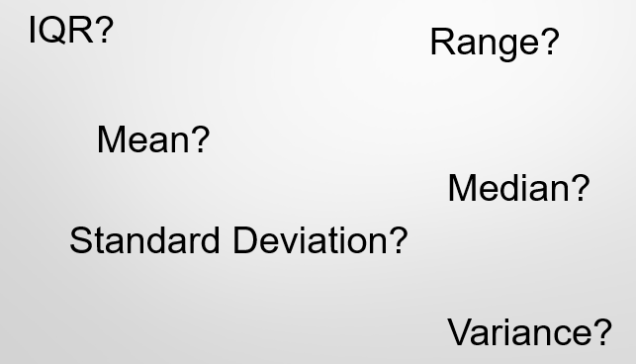
Example: CUSS for me! | Describe the distribution of the following:  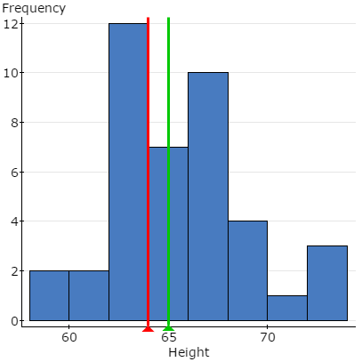  Mean Std. dev.  65.02439 3.4076224
Classwork: | Activity: Matching Statistics and Graphs  (Explain how you made your choices on a separate piece of paper for Activity 1 and 2)
Classwork: | Using 1-Var Stats on the Calculator
Classwork: | 1. Creating Ogives  2. Matching Ogives to Histograms - Rectangle Drop Method  (Take notes on the paper given)
Classwork/  Homework: | Chapter 3 Review for Test

