Name __________________________________________________ Date ______________
Intro to Statistics – Ms. Klimczuk
Chapter 3 Review for Test – Displaying and Summarizing Quantitative Data
- Students in a college statistics class responded to a survey designed by their teacher. One of the survey questions was “How much sleep did you get last night?” Here is the data (in hours).

9 6 8 6 8 8 6 6.5 6 7 9 4 3 4
5 6 11 6 3 6 6 10 7 8 4.5 9 7 7

- Make a dotplot of the data. Label your axis. Make sure to give a title.

- Describe the shape of the distribution: Is it unimodal, bimodal, or multimodal? Skewed or symmetric?

- What would you use to describe the center? The median or the mean? Why?

- What would you use to describe the spread? The IQR or the standard deviation? Why?

- Using your graphing calculator, write down the following:

The mean: ________________

The Standard Deviation: __________________

The Variance: _________________

The Median: __________________

1st Quartile: ___________________

3rd Quartile: ___________________

The Interquartile Range: __________________

- Are there any outliers? Justify your answer.

- Make a boxplot of the data. Label your axis. Make sure to give your graph a title.

- Which of the following boxplots best matches the distribution shown in the histogram?
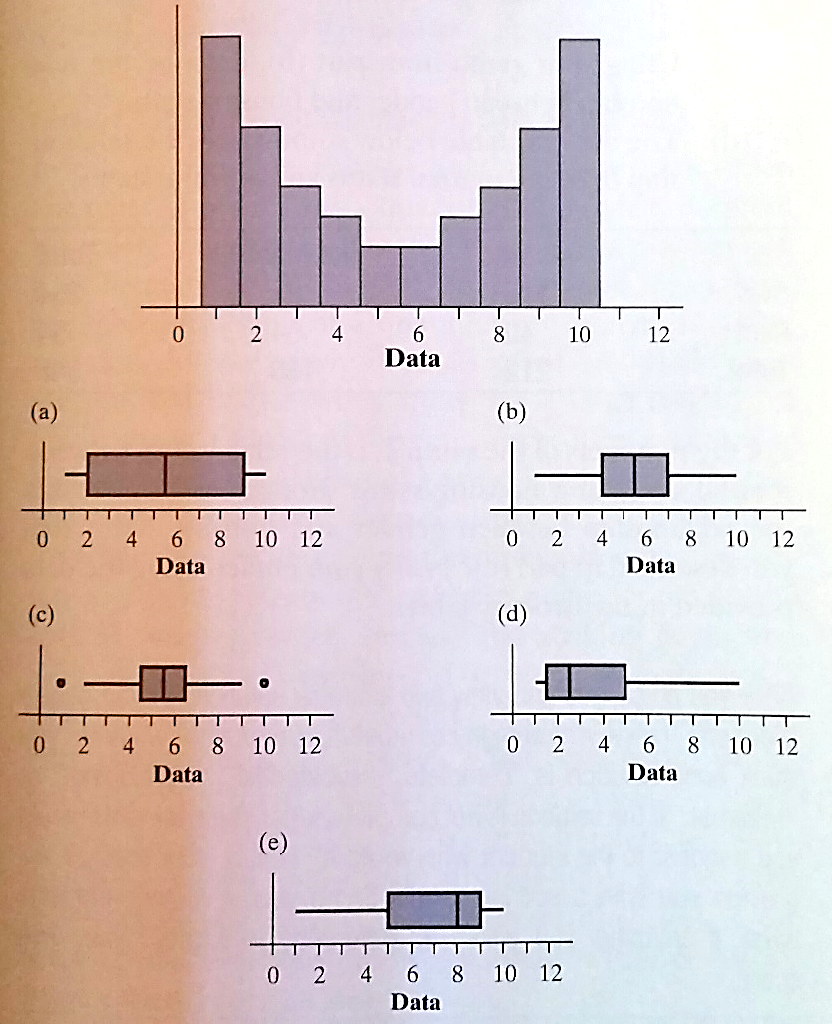
- The figure below is a cumulative relative frequency graph (ogive) of the amount spent by 50 consecutive grocery shoppers at a store.

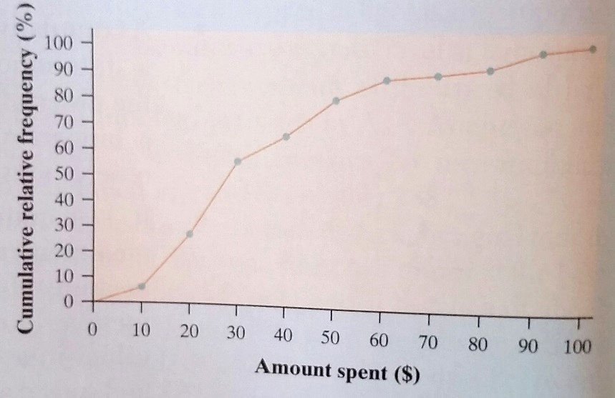

- Estimate the IQR of this distribution. Show your work.

- What is the percentile for the shopper who spent $19.50?

- Draw a histogram that corresponds to this graph. Label your axis.

- Use the 2 sets to answer the following questions.

Set 1: 3, 5, 6, 7, 9

Set 2: 2, 4, 6, 8, 10

- Without doing any calculations, decide which set would have the bigger standard deviation. Explain why.

- Find the standard deviations of both sets by hand. Show all of your work (use the standard deviation formula for a sample).

