Introduction to Statistics

Chapter 4: Understanding and Comparing Distributions
Date: ________________________________

Objectives:

Students will be able to compare groups and look for patterns among groups over time.

Students will understand that using histograms and stem-and-leaf plots are useful for comparing two distributions, but boxplots are more useful for comparing several groups.

Students will understand the value of identifying outliers.
Main Idea | Notes
The Big Picture | We can answer interesting questions about variables when we compare distributions  for ________________________________________________________________________.  Here is a histogram of the Average Wind Speed for each day in 1989.  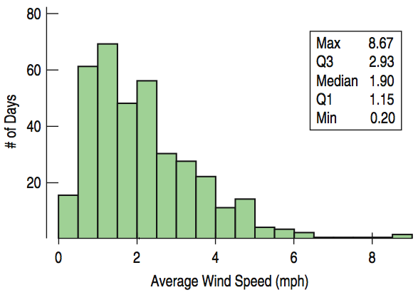  - Where is the mean?  - Describe the distribution of this data. (CUSS!)
Windspeed: Making Boxplots | Now here is the histogram & boxplot for daily wind speeds:  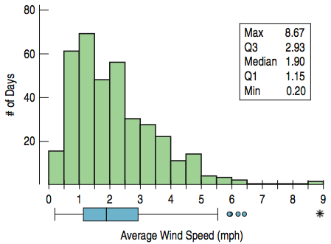  Explain what you see here…
Comparing Groups with Histograms | Sometimes it is more interesting to compare groups (here: spring/summer & fall/winter).  With histograms, we can note the _______________________, _____________________,  and _____________________________ of the two distributions.  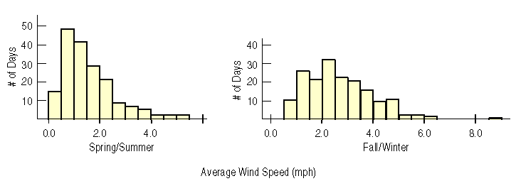  Compare the two distributions (CUSS comparatively).
Comparing Groups with Boxplots | Boxplots offer a nice balance of information and simplicity, displaying  _________________________________________________________.  We can plot them ____________________________________________ for groups or  categories that we wish to _______________________________ (in this case, by month).  Now, let’s say we are curious about the following questions: Are some months windier than others? Are wind speeds equally variable from month to month? Do some months show more variation?  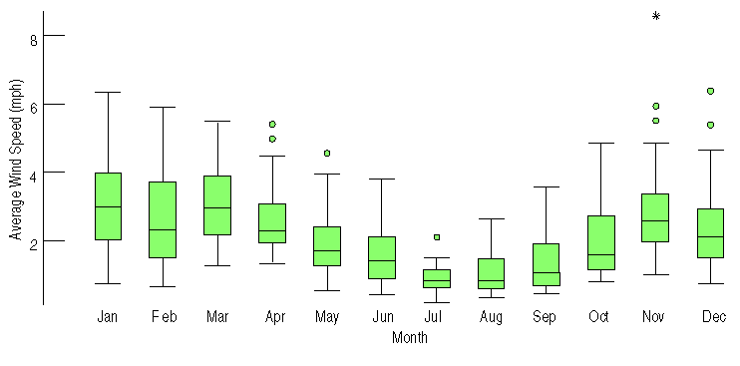  - What do you see here?  - Why do we now see outliers?  - When do wind speeds tend to decrease?  - When are winds the strongest and most variable?  - Why do you think there could have been an outlier in November?
What about Outliers? | If there are clear outliers and you want to report the mean and standard deviation,  report them with ____________________________________________________________________ and  with __________________________________________________________________________________. The  differences may be quite revealing.
Time Plots | For some data sets, we are interested in how the data behave ______________________.  In these cases, it may be helpful to construct ___________________________________  of the data. Here we are looking at calendar ‘year days’, starting on day 1.  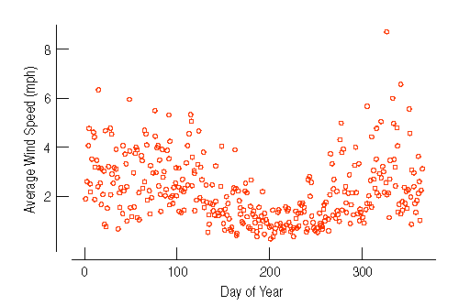  What do you see here?
Classwork: | Comparing Groups Worksheet
Re-expressing Skewed Data  Re-expressing Skewed Data  (Continued) | When data are ______________________________________________________________________ it can  be hard to summarize them using __________________________ and ___________________________,  and hard to decide whether extreme values are ___________________________________ or just  part of a _____________________________________________________________________. How can we say  anything useful about such data?  Look at the display below:  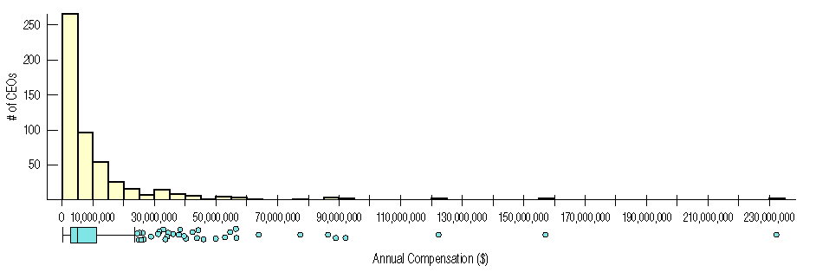  What do you see?  One way to make a skewed distribution more symmetric is to ____________________________  (transform) the data by applying some ______________________________________________________  (example: logarithm).  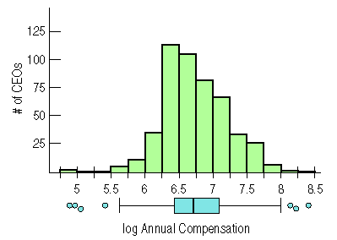  - Why is this re-expressed histogram better than the last one?  - We can now see that a typical log compensation is between about 6.5 and 7. What does this mean?
Some Log Examples (so you know how to work with logs): | $$\log_{10}x=y is equivalent to saying {10}^{y}=x$$  Solve for the variable.  - $\log{ 100=x}$  - $\log{ 1000=x}$  - $\log{ 10=x}$  - $\log{ x=3}$  - $\log{ x=5}$  - $\log{(annual compensation)=9}$  - $\log{(annual compensation)=3.6}$  - $\log{(annual compensation)=4.7}$
Classwork/  Homework | Chapter 4 Review for the Quiz  Study for the Chapter 4 Quiz (Next Class)

