Name ________________________________________________ Date ______________
Intro to Statistics – Ms. Klimczuk
Chapter 4 Review for Quiz: Understanding and Comparing Distributions
- The boxplots compare the daily returns (in percent) on a “total stock market” fund and a real estate fund over a one-year period.

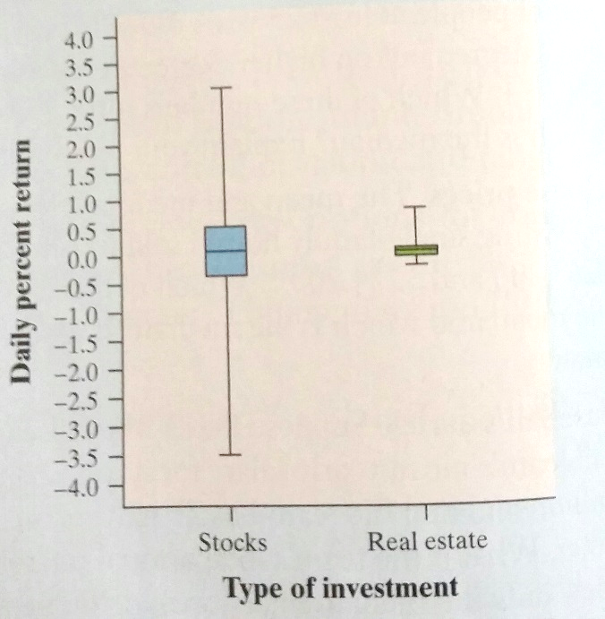

- Compare the two distributions using the center, shape, and spread.

- Would you put your money into a fund that buys stocks or a fund that invests in real estate? Why?

- Here are the scores on the Survey of Study Habits and Attitudes for 18 first-year college women:

154 109 137 115 152 140 154 178 101 103 126 126 137 165 165 129 200 148

Here are the scores on the Survey of Study Habits and Attitudes for 20 first-year college men:

108 140 114 91 180 115 126 92 169 146 109 132 75 88 113 151 70 115 187 104

- Compare the groups by making a back to back stem-and-leaf plot. Make sure to include a key and title.

- Do these data support the belief that men and women differ in study habits towards learning? Explain your reasoning using a description of your stem-and-leaf display.

- Here is a histogram of the assets (in one hundred thousands of dollars) of 79 companies.

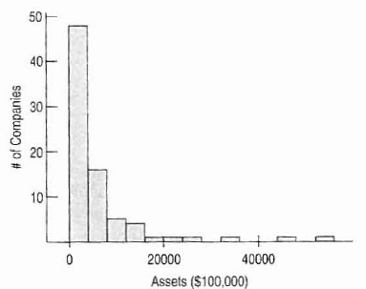

- What aspect of this distribution makes it difficult to summarize center and spread?

Use the following graph to answer part b) through part d).
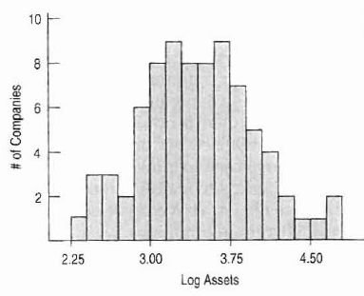

b) What did we do to the data in the first graph to get this one?

c) What are the benefits of doing this?

d) What does the value 4 in this graph actually indicate about the company’s assets?

