A class has been divided into groups of 5 students. Each group member has completed an individual 20-point quiz. Here are the scores on the quiz, by group:
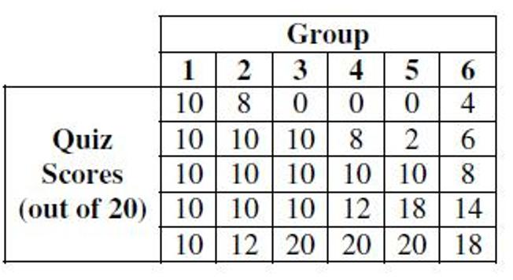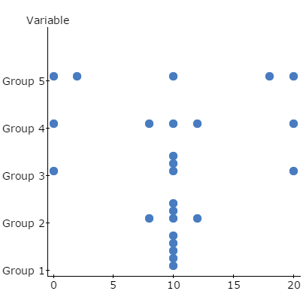
Group | 1 | 2 | 3 | 4 | 5 | 6
$$\overline{x}$$
Range
IQR
s_{x}

Let’s calculate the standard deviation of group 5 together by hand:
$$s(x)= \sqrt{VAR\left(x\right)} and VAR(x)=\frac{\sum{{(x-\overline{x})}^{2}}}{n-1}$$
$$x$$
$$x-\overline{x}$$
($x-\overline{x}$)²
$$\sum{{(x-\overline{x})}^{2}}$$
$$s^{2}=\frac{\sum{{(x-\overline{x})}^{2}}}{n-1}$$
$$s=\sqrt{\frac{\sum{{(x-\overline{x})}^{2}}}{n-1}}$$

Using a separate piece of paper (or the back), calculate the other 5 standard deviations (by hand). I will show you how to check your work using the graphing calculator afterwards.

